SAMARITAN HOUSE, 79 COPLAW STREET, GLASGOW, G42 7JG
TELEPHONE: 0141 636 3636 FAX: 0141 636 3685 EMAIL:CHECKIN@GOVANHILLHA.ORG
MARCH 2016
Date of Birth (DD/MM/YYYY)
Date of Birth (DD/MM/YYYY)
Office Use:
Ref
Wait / Trans / Sect 5 / S West
Size
HOUSING APPLICATION FORM
Title (Mr, Mrs, Miss etc)
You
Title (Mr, Mrs, Miss etc)
Joint Applicant
First Name
First Name
Surname or Family Name

PHOTO I.D. REQUIRED
Surname or Family Name

PHOTO I.D. REQUIRED

National Insurance Number
National Insurance Number
Phone Number
Phone Number
Mobile
Mobile
Email Address
Email Address
Current Address and Postcode |  |  | PROOF REQUIRED
 | Postcode

Current Address and Postcode |  |  | PROOF REQUIRED
 | Postcode

Correspondence address (if different from above)
Date You Moved In
Correspondence address (if different from above)
Date You Moved In

If yes, please give details Name of relative
Relationship to you Address
Phone number
Why do you need to be near a relative?
Who is your doctor (your GP)?
Their name

Address
Phone number
Office Use:
Specific Housing

Support
Do you want or need any of the following types of accommodation?
Amenity Sheltered Housing with access General housing housing for wheelchairs housing
No
Would your new home need any adaptations to meet your needs?
If yes, please provide
If you require sheltered housing, please tell us how you would benefit?
Yes
details below
If yes, please give details
Yes
No
Do you need to move to give or receive support?

Name of person you support or who supports you
Relationship to you Address
Phone number
Please detail the support arrangements
Do you want to move nearer a relative? No Yes

Are you under immigration control?
No
Yes
IF YES PROOF REQUIRED
Are you under immigration control?
No
Yes
IF YES PROOF REQUIRED
Are there any conditions or limits to your permission to stay in the uk?
No
Yes
Please provide details
Are there any conditions or limits to your permission to stay in the uk?
No
Yes
Please provide details
Do you receive support from a social worker or health professional?
No
Yes
Do you need to move closer to work, further education, or receive training?
No
Yes
If yes, please give details Their name
Occupation Organisation
Address
Phone number

What support do they provide?
If yes, please give details
Joint Applicant
You
Under the Housing (Scotland) Act 2001 and the Asylum and Immigration Act 1999, we must find out if a person qualifies for help provided from public funds, including housing.
Asylum and Immigration
Office Use:

Name 1

What is the medical condition?
Please explain - how is it affected by your current home?
What type of accommodation would improve the condition?
Name 2

What is the medical condition?
Please explain - how is it affected by your current home?
What type of accommodation would improve the condition?
In this section, please tell us if you or anyone who will be living with you has a medical condition that is affected by your current home. We may have to contact your doctor to verify the information you provide or for advice regarding the medical condition and rehousing requirements . Please provide as much information as possible.
Office Use:
Medical Priority

Full name
Current address and postcode
Date of Birth (DD/MM/YYYY)
Relationship to you
Date they moved in
Male
Female
Full name
Current address and postcode
Date of Birth (DD/MM/YYYY)
Relationship to you
Date they moved in
Male
Female
Full name
Current address and postcode
Date of Birth (DD/MM/YYYY)
Relationship to you
Date they moved in
Male
Female
Full name
Current address and postcode
Date of Birth (DD/MM/YYYY)
Relationship to you
Date they moved in
Male
Female
In the table below, give details of everyone who will move into your new home with you.
If you have shared access to children who live with you less than 50% of the time, you should not include them here. We will need to see proof. Please tell us about any particular arrangements in the extra information box on Page 16.
People who will be moving with you
Your Housing Details
Office Use:

Full name
Current address and postcode
Date of Birth (DD/MM/YYYY)
Relationship to you
Date they moved in
Male
Female
Full name
Current address and postcode
Date of Birth (DD/MM/YYYY)
Relationship to you
Date they moved in
Male
Female
Full name
Current address and postcode
Date of Birth (DD/MM/YYYY)
Relationship to you
Date they moved in
Male
Female
Full name
Current address and postcode
Date of Birth (DD/MM/YYYY)
Relationship to you
Date they moved in
Male
Female
Office Use:
People who will be moving with you (continued)

Please list your addresses over the last five years, starting with your most recent first. You do not need to list your current address.
Previous Addresses — You

Address
Address
Date moved in (DD/MM/YYYY)
Date moved out (DD/MM/YYYY)
Landlord’s name and address (if applicable)
Why did you move out?
Address
Date moved in (DD/MM/YYYY)
Date moved out (DD/MM/YYYY)
Landlord’s name and address (if applicable)
Why did you move out?
Address
Date moved in (DD/MM/YYYY)
Date moved out (DD/MM/YYYY)
Landlord’s name and address (if applicable)
Why did you move out?
Office Use:
Postcode

Postcode

Postcode

Postcode
Why did you move out?
Date moved in (DD/MM/YYYY)

Date moved out (DD/MM/YYYY)

Landlord’s name and address (if applicable)

Please list your addresses over the last five years, starting with your most recent first. You do not need to list your current address.
Previous Addresses — Joint Applicant

Address
Address
Date moved in (DD/MM/YYYY)
Date moved out (DD/MM/YYYY)
Landlord’s name and address (if applicable)
Why did you move out?
Address
Date moved in (DD/MM/YYYY)
Date moved out (DD/MM/YYYY)
Landlord’s name and address (if applicable)
Why did you move out?
Address
Date moved in (DD/MM/YYYY)
Date moved out (DD/MM/YYYY)
Landlord’s name and address (if applicable)
Why did you move out?
Office Use:
Postcode

Postcode

Postcode

Postcode
Why did you move out?
Date moved in (DD/MM/YYYY)

Date moved out (DD/MM/YYYY)

Landlord’s name and address (if applicable)

Full name
Date of birth (DD/MM/YYYY)
Relationship to you
Male
Female
Full name
Date of birth (DD/MM/YYYY)
Relationship to you
Male
Female
Full name
Date of birth (DD/MM/YYYY)
Relationship to you
Male
Female
Full name
Date of birth (DD/MM/YYYY)
Relationship to you
Male
Female
Full name
Date of birth (DD/MM/YYYY)
Relationship to you
Male
Female
Full name
Date of birth (DD/MM/YYYY)
Relationship to you
Male
Female
Full name
Date of birth (DD/MM/YYYY)
Relationship to you
Male
Female
Full name
Date of birth (DD/MM/YYYY)
Relationship to you
Male
Female
In the table below, give details of everyone who you currently live with who will not be moving into your new home with you.
People who currently live with you, but will not move with you
Office Use:

Your Current Amenities
Tick the boxes to show if you don’t have or share (with people who are not part of your household) any of these amenities in your current home:
Do not have Share Do not have Share
Living room
Cold water supply
Hot water supply
Inside toilet
Bath or shower
Kitchen
Bathroom
If you share amenities with others, how many people do you share with?
What type of heating do you have? Please tick one box:

Gas central heating Electric central heating
Other
(please give details)
Electric fire only
Gas fire only
Coal-fired central heating
Coal fire only

Please tick one box that best describes your present circumstances.
Your Current Circumstances — Applicant
PROOF REQUIRED

Are you?:
A Govanhill Housing Association tenant
A tenant with another housing association
A council tenant

Living with friends or relatives A lodger
Living in a hostel or bed and
breakfast
Serving in HM forces
Renting from a private landlord Living with parents
An owner occupier In hospital
Living in a caravan
In prison or another institution
Living in accommodation provided by your job
Date you will leave the forces
If you are a tenant, please provide details of your current landlord
Name

Address
Do you have a tenancy agreement?
Current Tenure
PROOF REQUIRED

Office Use:

How many bedrooms does your present home have?
Single
Double
Have you been given a date to leave your present accommodation?
No
Yes
If yes, on what date do you need to move out? (DD/MM/YYYY)
Please tell us why you need to move:
Is there a closing order over your present accommodation?
No
Yes
If there are any faults in your home that makes it not fit to live in, tell us about them in the box below. This could include structural faults, dampness, unsafe electrics, dry rot and so on. We may need to assess any problems.
IF YES, PROOF REQUIRED
What type of property are you living in? Please tick one box:
Flat (ground floor)
Basement flat
Flat (upper floor)
Attic flat
Bungalow
House (mid terrace)
Sheltered housing
House (end terrace)
Amenity housing
House (three storey)
House
(semi-detached)
Multi-storey flat
Four in a block (ground floor)
Four in a block (upper flat)
Maisonette (ground floor)
Maisonette (upper floor)
Studio flat
Office Use:

Do you need to move because you or someone living with you is experiencing harassment or domestic abuse?
No
Yes
Give further details below. We will keep the information confidential.
You may need to provide extra documents to support this information.
Social factors
Do you have access to children who may come and stay with you?
Please provide details
No
Yes
IF YES, PROOF REQUIRED
Are you, or anyone who is living with you expecting a baby?
No
Yes
If yes, who is expecting the baby?

When is the baby due?
PROOF REQUIRED OF DUE DATE
Office Use:

Has action for anti-social behaviour ever been taken against you or anyone who will live with you?
No
Yes
(If yes, please answer the questions below)
Was court action taken?
No
Yes
Date of case

Name of court
Was other action taken?
No
Yes
Was an anti-social behaviour order (ASBO) made?
No
Yes
Do you or anyone on your application form have to register with the police as a relevant offender under the Sexual Offences Act 2003?
No
Yes
If you or any member of your household must register under the Sexual Offenders Act 2003, you should send your form directly to
Housing Services Manager, Govanhill Housing Association, 79 Coplaw Street, Glasgow G42 7JG.

This does not mean that your application will get any less favourable treatment than you would otherwise receive.
Office Use:
Anti-social Behaviour

Office Use:
Street Choices

Street |  | Street
Aikenhead Road |  | Jamieson Court (sheltered housing complex), including Jamieson Path and Cathcart Road
Allison Street (west of Cathcart Road)
Allison Street (east of Cathcart Road) |  | Langside Road (north of Calder Street)
Annandale Street |  | Langside Road (south of Calder Street)
Annette Street |  | Preston Street
Ascog Street |  | Riccarton Street
Ardbeg Street |  | Seath Street
Bankhall Street |  | South Annandale Street
Batson Street (north of Govanhill Street) |  | Victoria Road
Batson Street (south of Govanhill Street)
Bennan Square
Boyd Street
Brereton Street
Butterbiggins Road
Calder Street (west of Cathcart Road)
Calder Street (east of Cathcart Road)
Carfin Street
Cathcart Road (north)
Cathcart Road (south)
Coplaw Court
Coplaw Street
Cuthbertson Street |  | Merrylee
Daisy Street |  | Ashmore Crescent
Dixon Avenue |  | Ashmore Road
Dixon Road |  | Burrelton Road
Garturk Street |  | Cherrybank Road
Govanhill Street (east of Cathcart Road) |  | Friarton Road
Govanhill Street (west of Cathcart Road) |  | Glasserton Street
Hickman Street (north of Calder Street) |  | Glasserton Road
Hickman Street (south of Calder Street) |  | Merrylee Road
Hickman Terrace |  | Muirskeith Crescent
Hollybrook Street (north of Govanhill Street) |  | Muirskeith Place
 |  | Muirskeith Road
Hollybrook Street (south of Govanhill Street)
 |  | Newlands Road
Inglefield Street
Jamieson Street
Kingarth Street

Would you consider a bedsit?
No
Yes
What kind of heating would you accept?
Gas central heating
Electric central heating
What cooking facilities do you prefer?
Either
Gas cooking
Electric cooking
What type of property do you want?
Four in a block (ground floor)
Four in a block (upper floor)
Flat (ground floor)
Maisonette
Flat (upper floor)
House
Which floor levels would you accept?
Please tick:
Ground First Second
Third
Four or more with a lift
Would you consider a combined living room/kitchen? No Yes

What size of property would you consider?
The Association’s allocation policy will decide what property size you are eligible for.
The Housing You Want
Office Use:

Office Use:
Other Information

Please detail any other information you feel may be relevant to your application

Equal Opportunities
Govanhill Housing Association is committed to open and equal access for everyone who is looking for housing from us. We monitor all applications for housing to make sure they reflect the needs of the population that we serve. You can help us to monitor equal opportunities by providing the following information. Please note, that your application will not be affected in any way if you choose not to answer any of these questions.

How would you describe the ethnic origin of your household? Please tick the appropriate box.
White | Asian
Scottish Other British Irish  Gypsy / Traveller Polish  Any other white background  Black, black Scottish, or black British  Caribbean African  Any other black background | Indian Pakistani Bangladeshi Chinese  Any other Asian background
 | Other ethnic background
Arab, Arab Scottish or Arab British
Mixed or Multiple ethnic background
Any other background
I would prefer not to answer this question
What is your preferred language?
Please tell us your nationality
Please tell us the nationality of the joint applicant (if applicable)
Yes
No
Do you consider yourself disabled?
Disability
Office Use:

Declaration
Are you related to a committee member or an employee of Govanhill Housing Association? (please tick)
No
Yes
If yes, what is their relationship to you?
Please provide their name and address Name
Address
Privacy Notice

Govanhill Housing Association Limited has registered under the Data Protection Act to enable us to process personal information about housing applicants and other service users. The Association must comply with the conditions set out in the Act.
You have the right to apply for a copy of the information we hold about you and to have any inaccuracies corrected. The Association may charge a fee for providing the information; the fee is limited by statute.
We use information from applicants and tenants for a range of purposes relating to our housing list and tenancy management. We will also use the information to provide statistical data to our Management Committee, the Scottish Housing Regulator, and other interested parties. We will always respect the confidentiality of the information you provide.
We may also use the information if you are successful in obtaining housing from Govanhill Housing Association. Your application details will be kept on file as “history notes”.
While you are on our housing list, and during any subsequent tenancy you have with the Association, we may add to or modify the information provided by you or others, for example, your landlord.
We may disclose your personal information to local authorities, police and other statutory bodies but only if they have a legal entitlement to the information. We may also share this information with local authorities in respect of matters relevant to a tenancy, or if you are claiming or receiving housing benefit.
By returning this form to us you consent to processing personal data about you in accordance with the Data Protection Act 1988.
Please read this declaration carefully
- I confirm that the details I have given on this application form are true and accurate.
- I understand that if my circumstances change, I must tell the Association.
- I understand that if I give any false or misleading information, my application will be cancelled.
- If I get a tenancy based on false or misleading information, I understand the Association may take court action to evict me.
- I understand that the Association can ask for a reference from any landlord or mortgage lender I have had. I authorise these landlords or mortgage lenders to provide any information required in connection with my application.
- I understand that this application will be cancelled when I accept a property offered through the register. If I want to move again, I know that I will have to make a new application.
- I understand that you will write to me every year, on the anniversary of my application, asking if I still want housing. I agree that if I do not respond to that letter, you will cancel my application.
Your signature
Date
Joint applicant’s signature
Date
Staff member
Date
Signatures. If you are applying with someone else, you must both sign or we will not process the form.

Proof Required

Please ensure all documentation is provided, otherwise we cannot fully assess your housing requirements and your application will be returned to you.

PROOF REQUIRED

Please see below types of proof we will accept:

Applicant 1 | Photo identification  (e.g. passport, driving licence)
Applicant 2 | Photo identification  (e.g. passport, driving licence)
Applicant 1 | Proof of address  (e.g. bank statement, benefits award letter, utility bill)
Applicant 2 | Proof of address  (e.g. bank statement, benefits award letter, utility bill)
Applicant 1 | * If required, proof of immigration status. All documentation from the UK Home Office
Applicant 2 | * If required, proof of immigration status. All documentation from the UK Home Office
Applicants or members of household who are pregnant | (e.g. Medical Letter)
Other household members | Proof of Address
Other occupants of address who are not moving | Proof of tenancy / ownership

Office Use:

We will consider the following examples of types of documentary proof:

Utility Bill, Tax Credit letter, Child Benefit letter, Medical Card, Job Seekers Allowance letter, Council Tax letter, Bank Statement, Drivers Licence, NHS letters (Hospital Appointments), HM Revenue and Customers — Tax for year, Payslips, Invoice receipt, Housing Benefit letter.

All documents must be from the address you are applying for housing.
You must fill in as much detail as possible to make sure we assess your housing need correctly. Where you see this symbol, it means you are required to provide two forms of documentation as evidence. We require photographic identification (eg passport or full driving licence). We also require proof of address. For example, full driving licence or bank statements.

PROOF REQUIRED

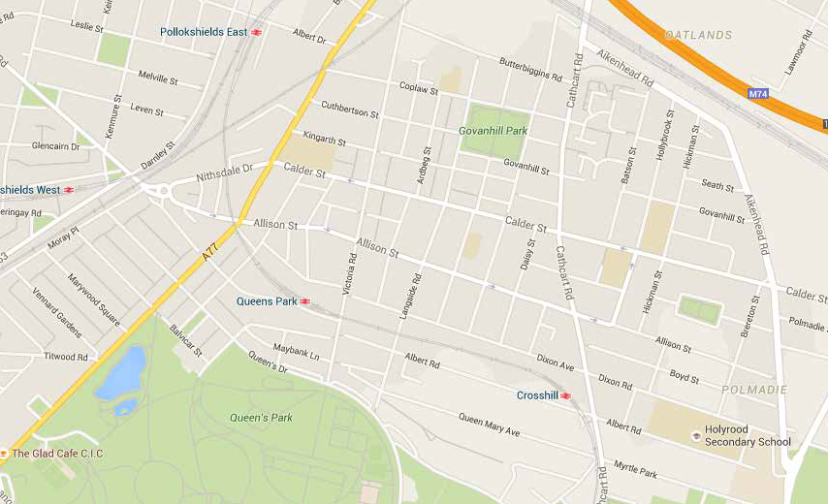
Govanhill lies to the south of the City Centre, to the east of Pollokshaws Road, close to Queens Park
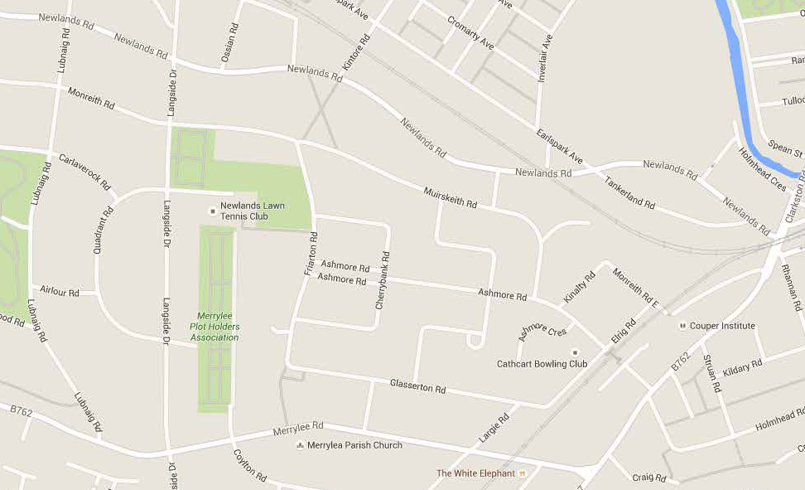
Merrylee lies to the south of the City Centre, betweem Cathcart Road and Kilmarnock Road, close to Cathcart and Shawlands

Govanhill Housing Association
Samaritan House 79 Coplaw Street
GLASGOW G42 7JG

General Enquiries - 0141 636 3636 Govanhill Housing Association is a Registered Charity No. SCO10307

