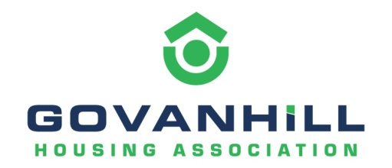

Close Cleaning Consultation

In the interests of good estate management, and to enable the Association to deliver our stated vision of ‘Everyone living in Govanhill and Merrylee should live in a neighbourhood that is clean and well cared for’, the Association is proposing extending stair and communal window cleaning to cover all our stock.

This measure will support the maintenance of our properties and the fabric of our buildings, as well as our partnership work with other agencies committed to improving and maintaining the common areas within Govanhill.

Do you agree? (please tick) | Yes
 | No

If No, please give reasons:

……………………………………………………………………………………………………………

……………………………………………………………………………………………………………

……………………………………………………………………………………………………………

This change will move stair and window cleaning from a service charge to a maintenance cost and as such it would be funded from rental income

Please advise if the following would be of interest to you.

Would you be interested in joining staff in a walkabout of your area to inspect closes, backcourts and the wider environment which would help both identify problems and develop solutions that benefit from local community knowledge?
Yes
No

Would you be interested in finding out more about tenant and resident participation opportunities – from taking part in one off focus groups to joining our Management Committee? Your local knowledge and expertise is essential in shaping services to meet the needs of our community.
Yes
No
Resident Feedback

We would appreciate your feedback on the close cleaning standard you would expect the Association to deliver.

Close Cleaning Specification

Proposed fortnightly tasks: please tick

- Door mats to be shaken to remove all surface dirt/litter. | Yes
 | No
- Brush and wash stairs: remove all dust, dirt and litter | Yes
ensuring all corners cleaned to prevent build-up of dirt. | No
- Front and rear steps to be brushed and washed. | Yes
 | No
- Minimum of two clean buckets of water to be used per close | Yes
with appropriate cleaning agents. | No
Weekly/fortnightly/other – please specify
……………………………………………………………………………………………..…

Proposed monthly tasks:

- Bannisters cleaned. | Yes
 | No
- Front and rear close doors including any side panels and the | Yes
door entry panel to be cleaned (all metal work/brasses | No
polished), glass panes washed.
- Ground floor close tiles both at the front and rear of the | Yes
close to be wiped down removing any dust and dirt. | No
- Windows washed inside and out. | Yes
 | No
- Cobwebs to be removed throughout. | Yes
 | No
Fortnightly/monthly/quarterly/other – please specify

………………………………………………………………………………………………

If you wish to be entered into our Prize Draw of five Cash Prizes of £20 please return this form by 1st April 2021 to ‘Freepost Better Living’ or email it in to checkin@govanhillha.org
Name: …………………………………………………………………………………………………..

Address: ………………………………………………………………………………………………..

The increased costs will be considered within the annual rent review.

